

Vision-Based Approach for

Robotic Manufacturing



Principal Investigator: Dr. Yahya Zweiri  Date: December 2021 | Approved by Director of ARIC:  Date:
Co-Principal Investigator: Dr. Irfan Hussain  Date: December 2021 | Approved by: ARIC Senior Management Board  Date of meeting:

PROJECT DEFINETION
In recent years, robotic technologies have become a competitive choice for a variety of industrial manufacturing processes due to their flexibility, cost-efficiency, mobility and large workspace volumes. STRATA Manufacturing PJSC is pioneering the application of robotics for precise manufacturing to automate several of its production lines. The robots STRATA deploys should be able to perform a variety of tasks including: drilling, deburring, painting, riveting, and inspection. STRATA has already deployed a robotic drilling systems (see Figure. 1) on multiple of its production lines; and through their previous collaboration with Khalifa University, the two entities have jointly investigated the extension to other machining processes. This document forms the Statement of Work for the continuation of this collaboration to develop qualification-ready robotic solutions for deburring, painting, riveting, and inspection; and research novel technologies for high quality robotic machining.
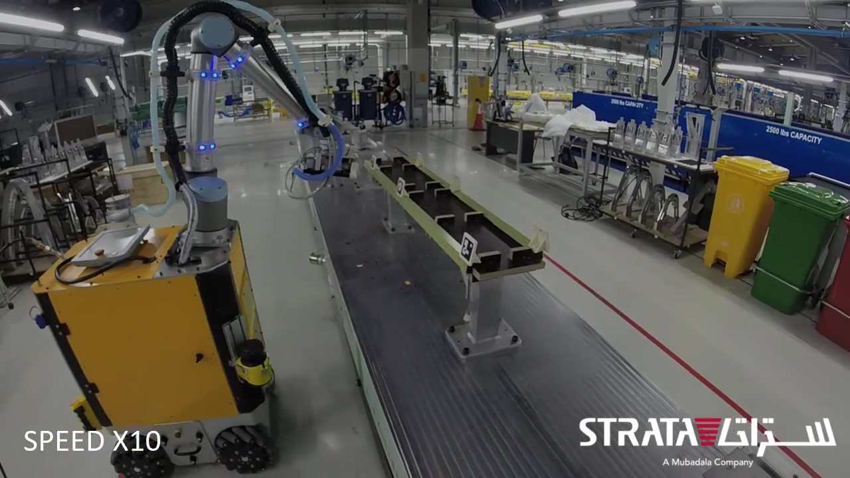
Figure 1. The nut-plate drilling robot currently deployed at STRATA’s B787 vertical fin production line.

The first task in scope will be upgrading the deburring end-effector. The team has already tested a first prototype for the deburring end-effector (see Figure. 2) that validates the design concept, but lacks sufficient clamping force during the deburring process. This in turn jeopardizes the stability of the end-effector and the precision of deburring. The team will be developing, testing and deploying a second iteration of the end-effector that incorporates a spring-loaded pressure-foot to ensure sufficient clamping for both stages of deburring (the front and blind side), and then modify the design according to the qualification requirements of STRATA’s clients. The team will also develop custom end-effector for the painting process of the inner surface of drilled holes. Several conceptual designs are currently being studied for the painting process, which will be followed by design selection, fabrication, and testing stages. Another process in consideration is riveting, and in particular blind (pop) riveting. The main challenge will be the requirement for applying sealant prior to installing rivets. The team will formulate multiple design concepts for this problem and then proceed upon consultation with the R&D team of STRATA. Finally, will be countersink inspection process for holes previously drilled by the robot. The team will study different inspection sensors and methods including 2D cameras and Laser Profilers to determine and deploy the most effective inspection solution.
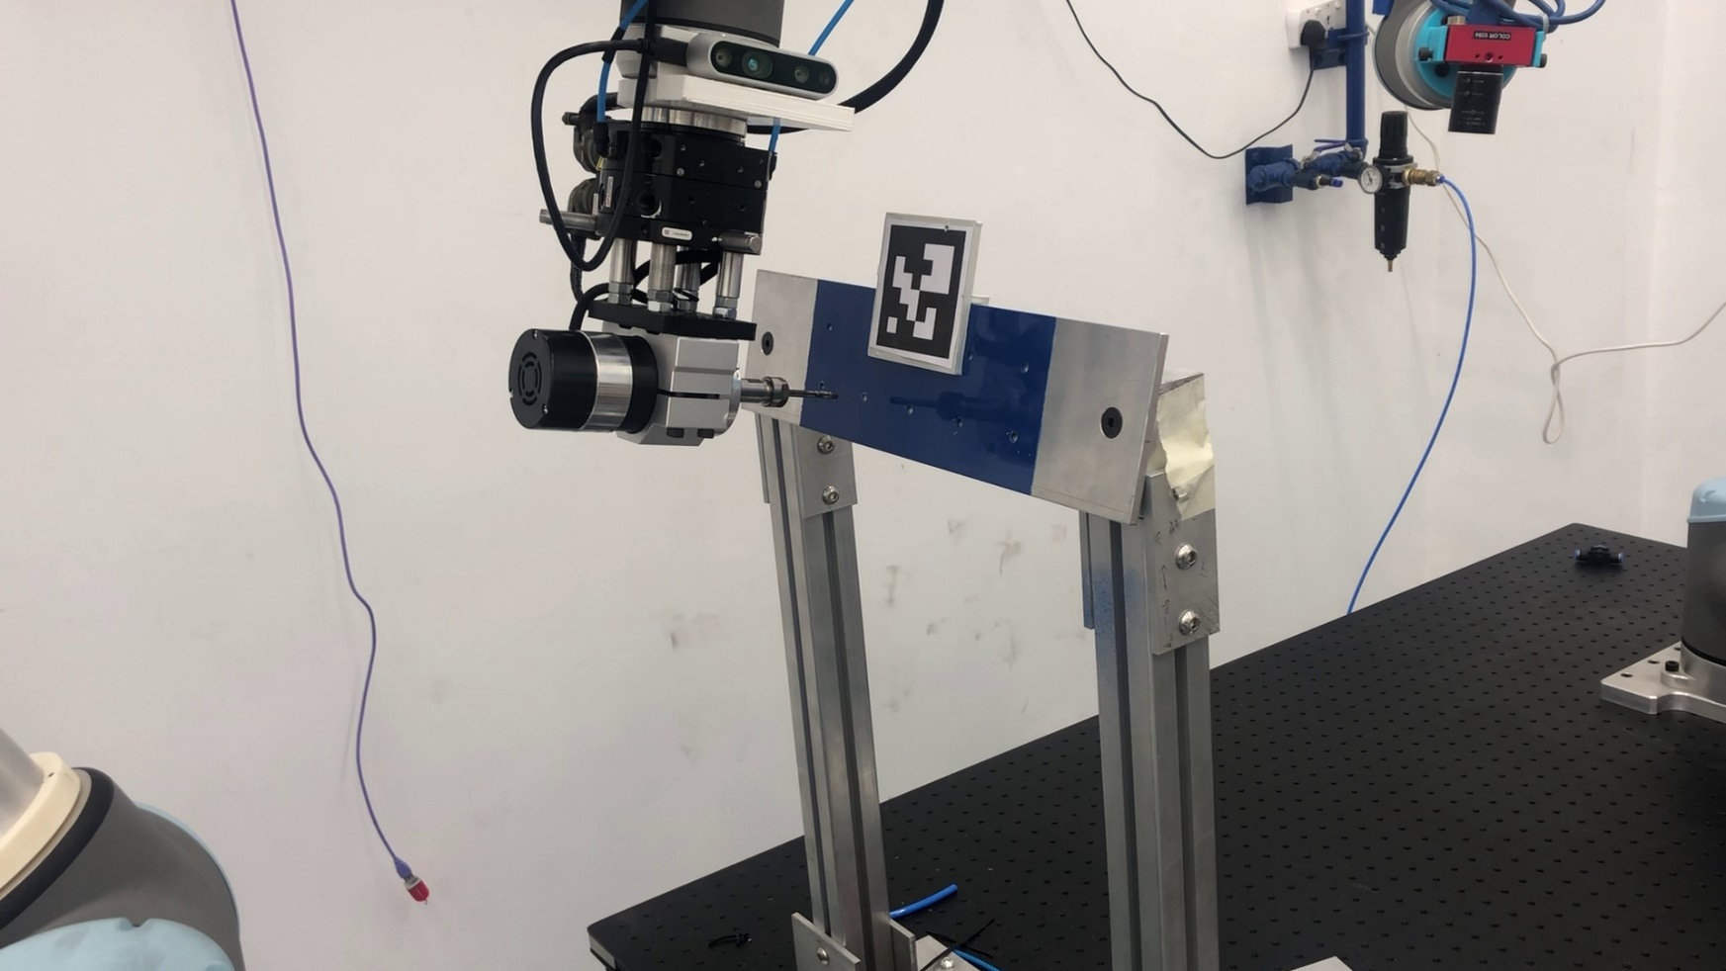
Figure 2. The first prototype of the deburring end-effector with the tool changing functionality.

Another work-package that will be running alongside the tasks mentioned above is the second stage of upgrading STRATA’s MMO-500 robot (shown in Figure. 3) up to the qualification requirements of STRATA’s clients. The major part of this upgrade has already been implemented during 2021, but several modifications are still required including changes to the electrical and electronic sub-system, the pneumatic sub-system, communication system, and the visual sensors. The robot will also be modified to enable it to perform multiple machining processes without the need for human support through tool-changing functionality.
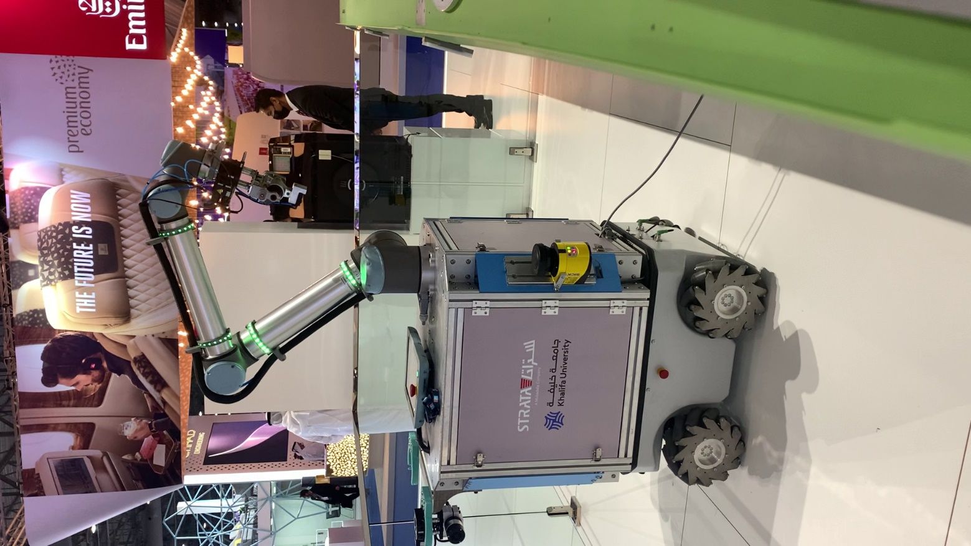
Figure 3. The MMO-500 robot upgraded at ARIC during the live demonstration at the Dubai Airshow.

In addition to the above development tasks, the project will involve research elements on novel technologies for robotic manufacturing and machining. First of which is the application of vision-based tactile sensing for contact measurement and control during different machining processes. This will build upon the previous patented technology and research conducted at Khalifa University to boost the technology readiness of visual tactile sensing. Other research aspects include the application of neuromorphic vision for robot navigation, guidance, and manipulation in industrial environments. In this line, we aim to introduce new technologies that can speed up surface inspection processes using neuromorphic vision and light coding.

Following the above requirements, the robotics team at Khalifa University will develop robotic machining solutions and customize them according to the needs of STRATA. The remainder of this document specifies the deliverables, required resources, budget, and timeline for this project.

OBJECTIVES
- The development of STRATA R&D MMO-500 robot to the qualification requirements.
- The development of the robotic deburring end-effector to the industrial specifications of STRATA.
- The development of a robotic painting end-effector for the inner-surface of drilled holes.
- The development of a robotic riveting end-effector.
- The development of a counter-sink inspection capability for the robotic machining platform.
- The research on dynamic vision optical sensing, as per our patent application 2020-034.
- The research on vision-based navigation to supplement the LiDAR system currently in use.
- The training of national Khalifa University students on robotic manufacturing technologies, including the mathematical fundamentals, robotic perception, mechanical design and the operation of robots in the industry.

APPROACH
This project involves multiple technical aspects of automation and robotics including: sensing & perception, robot guidance & manipulation, and mechanical design. In terms of sensing & perception, we will continue to use vision sensors as the main sensing elements, but will also test and evaluate other sensing technologies (e.g. laser profiles, LiDAR). For high TRL and industry-ready systems, we will use mature technologies such as 2D cameras, depth cameras, LiDARs, and laser profilers; while the research and academic activities will emphasize the Neuromorphic Dynamic Vision Sensor (DVS) which offers several advantage over conventional cameras in terms of dynamic range, latency, motion blur, and power consumption. Perception algorithms will be developed using the aforementioned sensor to meet the below objectives:
- Provide 3D reconstruction with sub-mm accuracy for inspection of pre-drilled holes
- Provide precise position adjustment of the end-effector with respect to the workpiece.
- Detect 3D obstacle in the environment and adjust robot behavior accordingly
- Aid the localization of the mobile robot (supplementary to the 2D LiDAR).
- Detect human operators in the surrounding environment and react accordingly.
Another major sensing technologies that we will investigate are visual tactile sensors and their applications in robotic machining. These sensors can convey contact information such as: forces, torques, normality, and slippage with high resolution, low-cost, and minimal weight. To evaluate the developed tactile sensors, we will use off-the-shelf force/torque sensors and laser trackers to provide ground truth measurements. We will assess visual tactile sensors in terms of their capability to meet the below objectives:
- Provide normal alignment of the end-effector during the machining process.
- Measure and regulate contact forces and torques.
- Evaluate the success and quality of machining process based on sensor feedback.
Finally, High quality mechanical design and fabrication will be of essence to this project as it involves the development of custom end-effectors for: deburring, painting, and riveting. The end-effectors will combine off-the-shelf equipment with in-house fabricated parts. For each of the end-effectors, several conceptual designs are being studied and will be developed upon consultation with STRATA’s R&D team.

DELIVERABLES
- Upgrade STRATA’s MMO-500 robot to be qualification-ready.
- Fully functional and qualification-ready prototypes for:
- Deburring End-Effector.
- Painting End-Effector
- Blind Riveting End-Effector
- Counter-sink inspection.
- A journal paper that documents the multi-function robot machining system
- A journal paper that presents the first use of vision-based tactile sensing for normality control in machining applications.

HUMAN RESOURCES
Resource | Allocation
Dr. Yahya Zweiri (PI) | 10%
Research Assistant 1 | 100%
Research Assistant 2 | 100 %
Student Involvement (Undergraduate) | 3 to 4 students

GANTT CHART
Work Package | Month
 | 1 | 2 | 3 | 4 | 5 | 6 | 7 | 8 | 9 | 10 | 11 | 12
The modification and upgrade of the deburring end-effector.
The development of the painting end-effector
The development of the blind riveting end-effector
Counter-Sink inspection using: a) camera. b) laser profiler
Neobotix MMO-500 preparation for qualification
Vision based navigation of mobile robot
Vision Based Tactile Sensing for normality control
Vision Based Tactile Sensing for force/torque estimation and regulation
Neobotix MMO-500 preparation for qualification
Project Closure and recommendations
- The Gantt Chart is subject to the date of initiation of the project.

ESTIMATED BUDGET inc all costs such as manpower, opex and capex
CAPEX | 150,000 AED*
OPEX | 150,000 AED
Manpower | Equivalent to 2 Research Associates
- Assuming that STRATA would be able to provide/lend a serial robot manipulator to Khalifa University.

EQUIPMENT REQUIREMENTS
- Two serial robotic manipulators (including the UR10 already available at KU)
- Neobotix MMO-500 mobile robot (available at STRATA)
- High resolution cameras
- Neuromorphic cameras
- 2x ATI Force/Torque sensor
- 2x Laser profiler
- LEICA AT960 laser tracker (available at ARIC)
- LEICA Absoluate Scanner LAS
- 2x 3D printer for rapid prototyping (Higher quality printers are required in place of the older Zortax M200)

PROJECT SPECIFIC SMART KPIs
- Two journal articles in Q1 journals.
- Fully functional and qualification-ready prototypes for: A) Deburring End-Effector. B) Painting End-Effector. C) Blind Riveting End-Effector. D) Counter-sin inspection.
- The training of 3-4 undergraduate students.

PROGRESS REPORTING

- Progress reports - Monthly progress reports will be prepared by the PI and submitted to the project lead per email at the end of each month.
- Interim technical report after 6 months. Final technical report at the end of the project.
- Technology demonstrations for STRATA R&D reviews and VIP visits to ARIC
- Full documentation of robot hardware & software to be provided at the end of the project.

